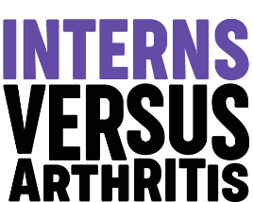
@MSKInterns

Nurse and Allied Health Professionals
Internship Programme - Summer 2022

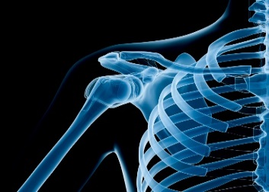 | 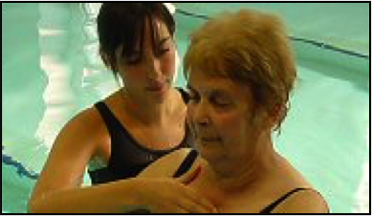  Are you interested in clinical research about Rheumatic & Musculoskeletal Diseases (RMDs)?  If you are a final year student or have graduated within the last five years in Nursing or an Allied Health Profession  (UK NMC & HCPC registerable)…  If you have a 1st or 2:1 degree (or predicted) or an equivalent academic  achievement if you are a nurse…  …You could qualify for an internship with Versus Arthritis!

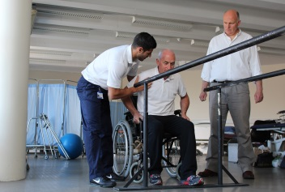
Seven international research institutions renowned for RMDs research (Universities of Southampton, Glasgow Caledonian, Keele, Leeds, Oxford, Salford, and the West of England) have collaborated to host 8 interns across the UK each year
The programme provides opportunities to:
- Learn and experience how RMD research relates to your clinical practice
- Obtain first-hand experience of working with a Centre of Excellence of RMDs research via a blended approach of on-line and face-to face contact (dependent on Government guidelines)
- Attend actual/virtual site visits & receive supervision, evaluation & post-programme mentoring in research
- Participate in multi-professional research seminars, conferences and workshops
- Become part of a specialist network of RMD researchers and intern alumni

The programme aims to address existing deficiencies in RMDs clinical research by bringing together experts in all AHPs and Nursing to develop the next generation of RMDs researchers and clinical specialists. Successful interns will be at the forefront of research into Musculoskeletal health. The placements are unpaid but each intern will receive £1000 towards costs.

“The Versus Arthritis Internship programme was a great opportunity as it enabled me to build my experience in research, work with leading UK researchers and network with other interns” (Quote from Intern, 2019).

For further information: Watch the video: https://youtu.be/yIzrIu6SLNc
Contact: Mary Fry (MSc) - Programme Manager m.l.fry@soton.ac.uk
Programme dates: 8 weeks full-time equivalent between June-Sept with core training dates in July and Aug. Flexible and part-time options available
Application Deadline: 16th Feb Interview date: 30th March (conducted remotely)
