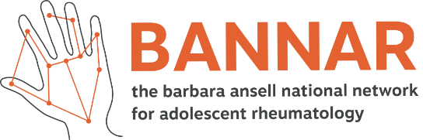
BANNAR Members Research Activity
Please complete the details below if you would like your research to be included in the BANNAR AYA research portfolio. This is a very helpful resource that will inform the network of what is currently happening in our research landscape, as well as facilitating relevant collaboration. If you are running multiple projects, please use a separate form per research project.

Name:
Are you a BANNAR member? YES/NO

Age Inclusion Criteria of your research: YES/NO (delete as appropriate)
Adolescent only (10-19 years) YES/NO young adult only (16–24-year-olds) YES/NO
adolescent and young adult only (10-24) YES/NO
If other broader age ranges, please give information regarding what AYA specific research questions are being addressed:

Does your research address specific adolescent related/ young adult developmental issues? YES/NO (delete as appropriate)

Is your research taking place in the UK? YES/NO
Which of the four nations in the UK is this research taking place?
England Scotland Wales N Ireland

Type of activity (please highlight the relevant areas below)
Basic science Psychosocial
Clinical research Transitional care
Clinical trial Vocational
Observational research study Pain
Epidemiology Involvement of Young People
Public health
Health service research

Title of project:

Name of host institution:

Lead Researchers name and profession:

Lead Researcher Location:

Status of research: (please highlight the relevant areas below)
Design stage
Submission preparation stage
Application submitted
Ongoing
Funded
Completed
Other

Funding Body (if applicable):

Research start date:
Research end date:

Research Description: e.g., lay summary

Link to research: e.g., website

For any questions, please email Sarah Yorke, BANNAR Project Officer: s.yorke@versusarthritis.org

